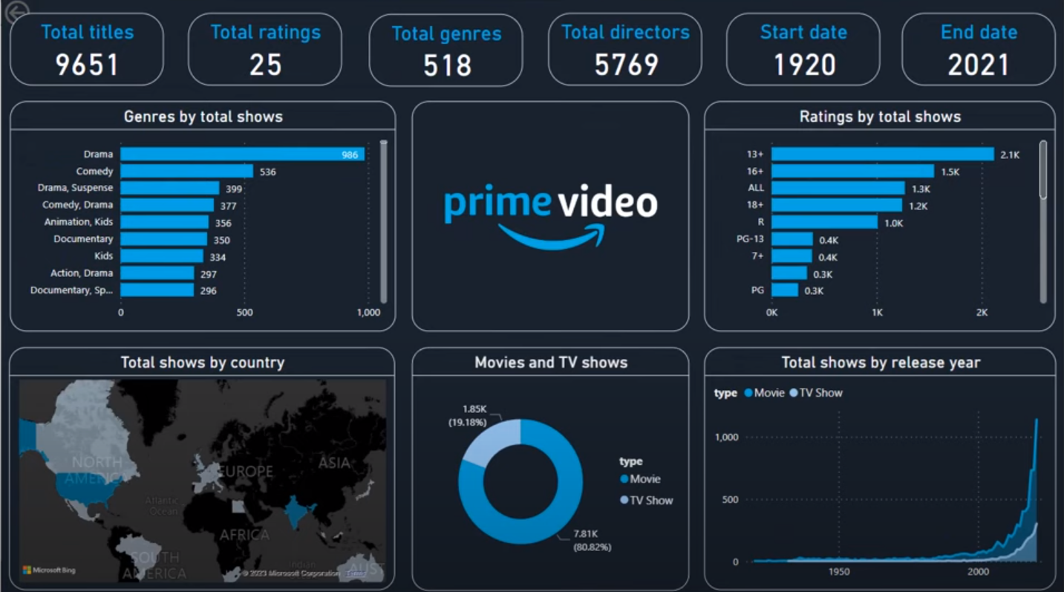

* **Total Titles:** 9,651
* **Total Ratings:** 25
* **Total Genres:** 518
* **Total Directors:** 5,769
* **Start Year:** 1920
* **End Year:** 2021

**Key Visuals:**

* **Genres:**
  + Most popular genres are *Drama* (986 shows), *Comedy* (536), and *Drama, Suspense* (399).
* **Ratings:**
  + Most shows are rated *13+* (2.1K titles) and *16+* (1.5K titles).
* **Geography:**
  + The U.S. and India seem to dominate the content distribution by country.
* **Content Type:**
  + *TV Shows* dominate (80.82% = 7.81K titles) compared to *Movies* (19.18% = 1.85K titles).
* **Release Year Trend:**
  + There's a **huge spike** in the number of releases after 2000, especially near 2020